**TASK FIVE:**

**FILE HANDLING AND EXCEPTION HANDLING**

1. Write a program in Python to allow the error of syntax to go in exception. HINT: use SyntaxError
2. try:
3. x = int(raw_input("Please enter a number: "))
4. print("%s squared is %s" % (x, x**2))
5. except SyntaxErroras error:
6. print(error)
7. else:
8. print('Executing the else clause.')

2. Write a program in Python to allow user to open a file by using argv module. If the entered name is incorrect throw an exception and ask them to enter the name again. Make sure to use read only mode.

try:

f = open('check_file.txt')

except Exception:

print("The file is not found")

else:

print(f.read())

f.close()

3. Write a program to handle an error if the user entered the number more than four digits it should return “Please length is too short/long !!! Please provide only four digits”

import string

import math

def fourDigit():

num = input("Enter the Digits: ")

if len(num) == 4 and all(c in string.digits for c in num):

print("You have entered 4 digits")

else:

print("Lenght of digits is too long or short")

fourDigit()

Output:

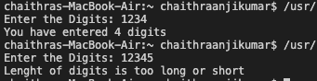

4. Create a login page backend to ask user to enter the UserEmail and password. Make sure to ask Re-Type Password and if the password is incorrect give chance to enter it again but it should not be more than 3 times.

print('Enter correct username and password to continue')

count = 0

password = ""

username = ""

# looping will continue when wrong input for three times and ask again

while password!='Hytu76E' and username!='bank_admin' and count < 3:

username = input("Enter username: ")

password = input("Enter password: ")

if password=='Chai@123' and username=='my_login':

# if match, grand and break

print('Access granted')

break

else:

print('Access denied. Try again.')

count+=1

Output:

For showing Access denied:

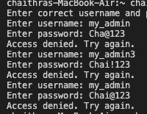

For showing Access granted:

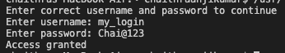

5. <https://www.programiz.com/python-programming/exception-handling> Go through this link to understand Finally and Raise concept.

6. Read any file using Python File handling concept and return only the even length string from the doc.txt file.  
Consider the content as:

Hello I am a file

Where you need to return the data string

Which is of even length

Make sure you return the content in The same link as it is present.

# open file in read mode

fn = open('inputfile.txt', 'r')

# open other file in write mode

fn1 = open('outputfile.txt', 'w')

# read the content of the file line by line

cont = fn.readlines()

type(cont)

for i in range(0, len(cont)):

if(i % 2== 0):

fn1.write(cont[i])

else:

pass

# close the file

fn1.close()

# open file in read mode

fn1 = open('outputfile.txt', 'r')

# read the content of the file

cont1 = fn1.read()

# print the content of the file

print(cont1)

fn.close()

fn1.close()

Output:

